Business Requirements Document (BRD)
Order-to-Cash (O2C) & Inventory Automation System | Client (fictional): PT Maju Distribusi Nusantara | Prepared by: Alief Sukma Dewanta, Business Analyst | Version 1.0 |
Portfolio note: the client is fictional. All baseline figures are simulated assumptions used to demonstrate the analysis method. This BRD describes the business need and what the business requires. How the system behaves is specified in the companion Functional Specification Document (FSD).

1. Document Control
Item | Detail
Document | Business Requirements Document
Companion document | Functional Specification Document (FSD), same project
Status | Draft for stakeholder review
Target solution | Odoo ERP (Sales, Inventory, Purchase, Invoicing)
Methodology | Hybrid: Waterfall for documentation, Agile sprints (2 weeks) for configuration
Version history
Version | Date | Author | Change
0.1 | Nov 2026 | A. S. Dewanta | Initial draft
1.0 | Nov 2026 | A. S. Dewanta | Split from combined BRD/FSD; business requirements added
Approvals required
Role | Name | Decision | Date
Operations Director (sponsor)
Sales Manager
Warehouse Supervisor
Finance Manager

2. Executive Summary
PT Maju Distribusi Nusantara distributes fast-moving consumer goods to about 350 retail stores in East Java. Orders arrive by WhatsApp, stock is tracked in an Excel file updated once a day, and invoices are prepared by hand. As a result, items are sold that are not in stock, orders are lost or mistyped, and invoices reach customers one to two days after delivery.
This project replaces the manual chain with one system that checks and reserves stock when an order is confirmed, tells the warehouse what to pick, issues the invoice when goods ship, and shows management how the process performs. The business targets are an order processing time under 2 hours (from about 24), overselling below 1% of orders, stock accuracy of at least 98%, and invoices sent within 15 minutes of shipment.

3. Business Context and Problem Statement

3.1 Company Profile (simulated)
One central warehouse, 18 sales representatives, a 6-person warehouse team, a 4-person finance team, about 250 orders per day, about 400 SKUs.

3.2 Business Context Diagram
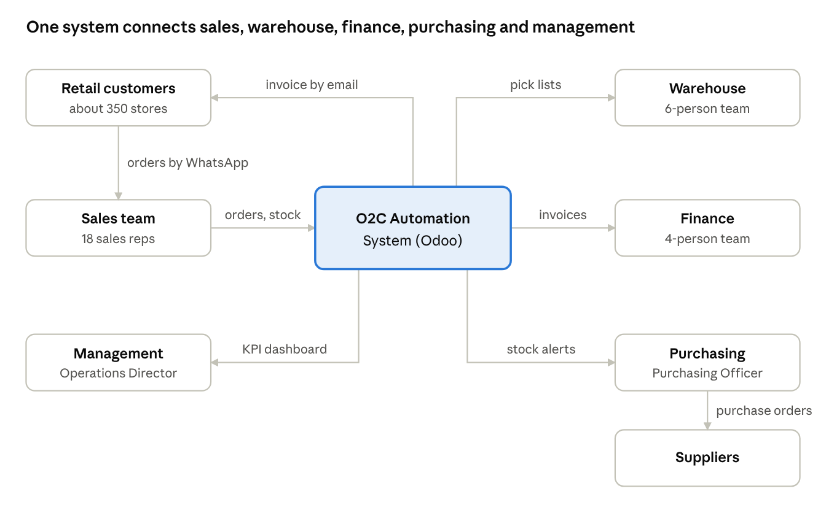
business context · 7 parties around the O2C system

3.3 Current Process (AS-IS)
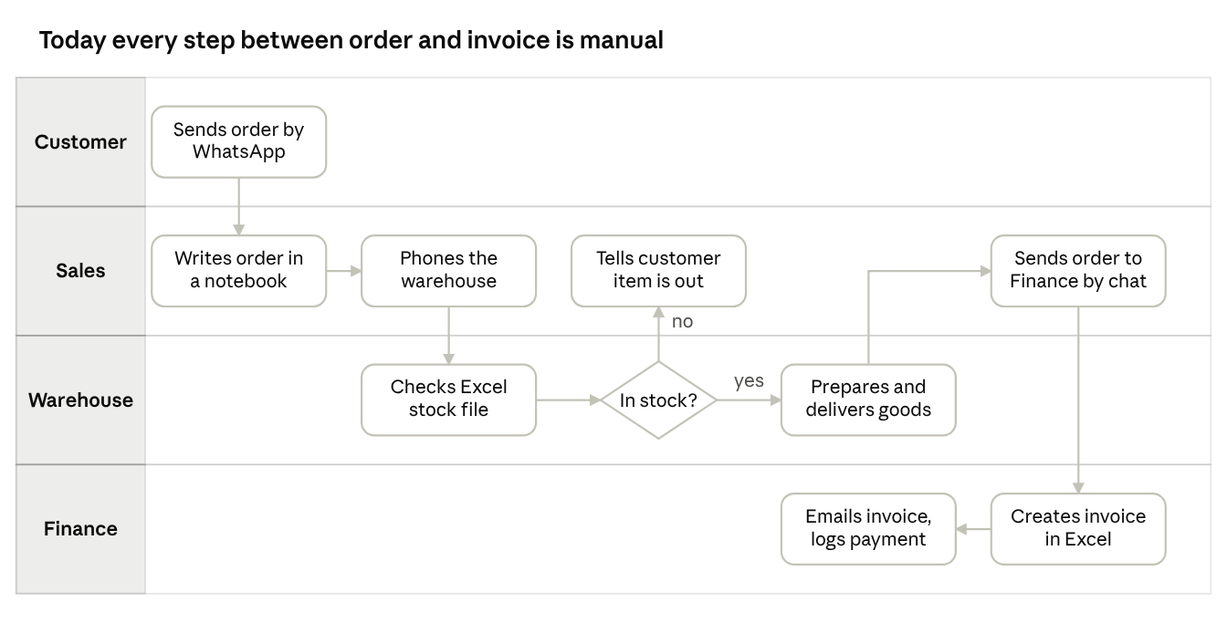
AS-IS process · 4 lanes, 9 manual steps
- Manual order intake. Customers send orders by WhatsApp. Sales representatives copy them into a notebook or spreadsheet, so orders are lost, duplicated, or mistyped.
- Siloed stock data. The warehouse tracks stock in Excel, updated once at end of day. Sales has no real-time view of availability.
- Overselling. Items are promised to customers while physical stock is zero or already allocated.
- Delayed invoicing. Finance waits for sales to forward order data and creates invoices manually, often 1 to 2 days after delivery.
- No audit trail. Order changes, cancellations, and stock adjustments are not recorded, so disputes are hard to resolve.
- Reactive purchasing. Replenishment starts only after a stockout is noticed.

3.4 Baseline Metrics (simulated)
Metric | AS-IS baseline
Average order processing time (order received to warehouse pick instruction) | 24 hours
Overselling incidents | 9% of orders
Stock record accuracy (system vs physical count) | 88%
Invoice issuance delay after shipment | 1.5 days
Orders with data-entry errors | 6%

4. Business Objectives and Success Metrics
ID | Objective | Metric | Target | Measured by
BO-01 | Reduce order processing time | Average time from order confirmation to pick instruction | Under 2 hours | System timestamps, dashboard
BO-02 | Eliminate overselling | Orders confirmed without sufficient stock | Under 1% | Order and reservation logs
BO-03 | Improve stock accuracy | System vs physical count | At least 98% | Cycle count reports
BO-04 | Accelerate invoicing | Time from shipment to invoice sent | Under 15 minutes | Invoice timestamps
BO-05 | Reduce order data errors | Orders needing manual correction | Under 1% | Order amendment log
BO-06 | Proactive replenishment | Stockout events per month | Reduce by 70% | Inventory reports

5. Scope

5.1 In Scope
- Customer and product master data
- Order capture, stock validation, and stock reservation
- Warehouse picking, packing, and shipment confirmation, including partial shipments
- Automated invoicing, payment recording (including partial payments), and receivables aging
- Low-stock alerts and purchase request generation
- Order cancellation, returns, and credit notes (basic)
- Role-based access control and audit log
- Operational KPI dashboard

5.2 Out of Scope
- Payment gateway integration (payments are recorded manually)
- Transport routing and fleet management
- Full accounting and tax filing
- Customer-facing mobile app (possible phase 2)
- Multi-warehouse support

6. Stakeholders
Stakeholder | Role in project | Influence | Interest | Engagement
Operations Director | Sponsor | High | High | Manage closely
Sales Manager | Key user, approver | High | High | Manage closely
Warehouse Supervisor | Key user | High | High | Manage closely
Finance Manager | Key user, approver | High | High | Manage closely
IT Administrator | Support, access control | High | Low | Keep satisfied
Sales Representative | End user | Low | High | Keep informed
Warehouse Admin | End user | Low | High | Keep informed
Finance Staff | End user | Low | High | Keep informed
Purchasing Officer | End user | Low | High | Keep informed
Retail Customer | External, indirect | Low | Low | Monitor
Influence and interest ratings are the analyst's assumptions for this simulated engagement and would be validated with the sponsor in a real project.
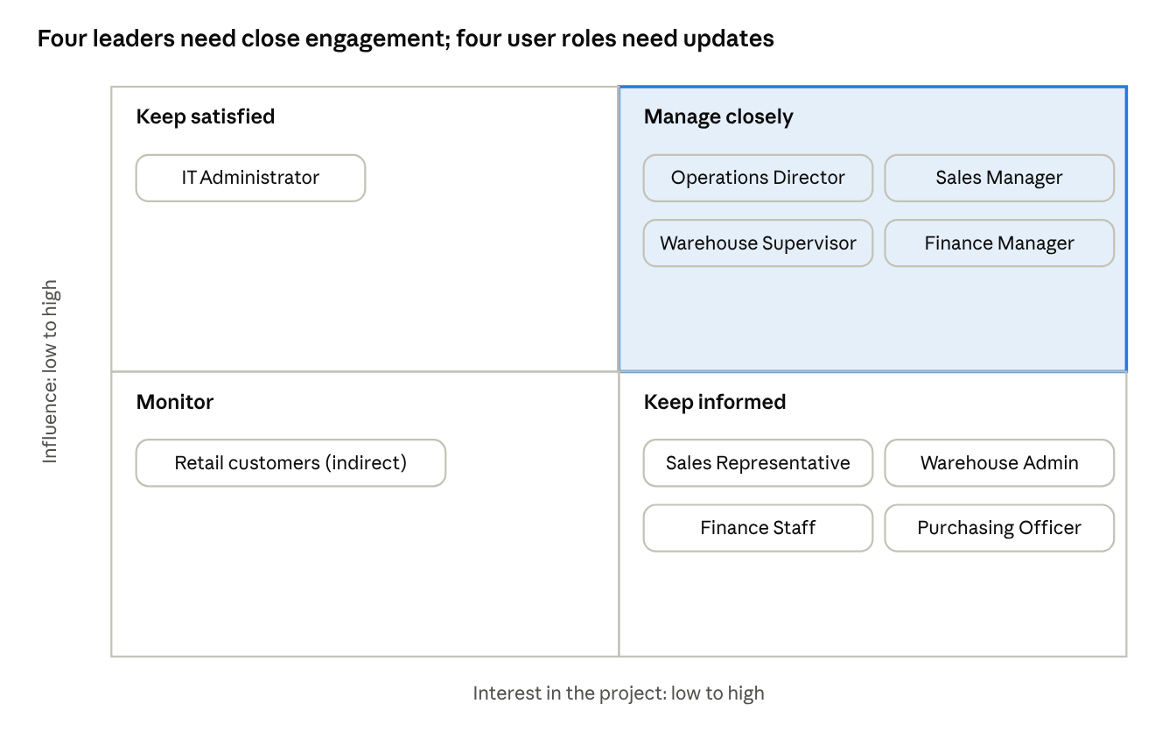
stakeholder map · influence and interest ratings are analyst assumptions

7. Business Requirements
Business requirements state what the business needs, independent of how the system does it. Each links to a business objective and is detailed as functional requirements in the FSD.
ID | Business requirement | Priority | Objective | FSD reference
BRQ-01 | Orders from customers shall be captured in one system with validated data. | Must | BO-05 | Master Data, FR-ORD-01, FR-ORD-04
BRQ-02 | Sales staff shall see current stock availability while taking an order. | Must | BO-01, BO-02 | FR-ORD-02, FR-INV-01
BRQ-03 | The business shall not accept orders for more stock than is available. | Must | BO-02 | FR-ORD-03
BRQ-04 | Stock promised to one customer shall be held for that customer. | Must | BO-02, BO-03 | FR-INV-02 to FR-INV-04
BRQ-05 | Large orders, high discounts, and credit risk shall be approved by management. | Must | Governance | FR-ORD-05, FR-ORD-06
BRQ-06 | The warehouse shall be told what to pick without phone calls and shall be able to ship partially. | Must | BO-01 | FR-SHP-01 to FR-SHP-05
BRQ-07 | Customers shall be invoiced automatically when goods are shipped. | Must | BO-04 | FR-FIN-01 to FR-FIN-03
BRQ-08 | Finance shall track payments, including partial payments, and overdue invoices. | Must | BO-04 | FR-FIN-04, FR-FIN-07
BRQ-09 | Returns and invoice corrections shall be traceable, without editing sent invoices. | Should | Governance | FR-SHP-06, FR-FIN-05, FR-FIN-06
BRQ-10 | Purchasing shall be warned before stock runs out. | Must | BO-06 | FR-INV-06
BRQ-11 | Stock records shall stay accurate through receipts, adjustments, and counts. | Must | BO-03 | FR-INV-05, FR-INV-07 to FR-INV-09
BRQ-12 | Management shall see KPIs that show whether objectives are met. | Should | All | FR-RPT-01 to FR-RPT-04
BRQ-13 | Access shall be limited by role and critical changes shall be logged. | Must | Governance | FR-SEC-01 to FR-SEC-04

8. Proposed Solution (TO-BE)
One ERP system holds customers, products, stock, orders, shipments, and invoices. The main changes to the process are:
- Sales enters each order once and sees available stock immediately.
- The system blocks orders that exceed available stock and reserves stock when an order is confirmed.
- Exceptions (large orders, high discounts, credit limit) go to the Sales Manager for approval.
- The warehouse receives a pick list automatically and can ship in parts.
- The invoice is created and emailed when the shipment is marked shipped.
- Low stock creates a draft purchase request.
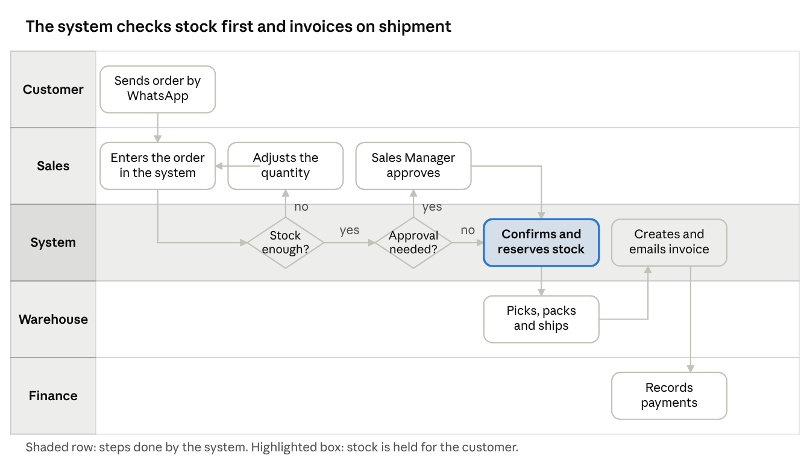
TO-BE process · 5 lanes, 2 decisions

8.1 Process Improvement Summary
Pain point | Root cause | Business solution | Objective
Order errors | Manual re-typing | Single order entry with validation | BO-05
Interruptions | Stock queries by phone | Live available stock on the order | BO-01
Stale stock data | End-of-day Excel update | Real-time stock levels and movements | BO-03
Overselling | No reservation | Block on insufficient stock, automatic reservation | BO-02
Delayed invoicing | Manual hand-off | Invoice created at shipment | BO-04
No payment visibility | Spreadsheet records | Payment status and receivables aging | BO-04
Reactive purchasing | No reorder trigger | Low-stock alert and draft purchase request | BO-06

9. Business Rules
ID | Rule
BR-01 | An order cannot be confirmed if requested quantity exceeds available stock (on hand minus reserved).
BR-02 | Confirming an order reserves stock immediately; reserved stock cannot be allocated to another order.
BR-03 | A customer whose overdue balance exceeds their credit limit cannot have new credit orders confirmed without Sales Manager approval.
BR-04 | Orders above IDR 50,000,000 require Sales Manager approval before confirmation.
BR-05 | An invoice is generated only when an order, or a partial shipment, is marked Shipped.
BR-06 | Cancelling a confirmed order releases its reserved stock. Cancellation after shipment is not allowed; a return must be used instead.
BR-07 | Available stock below the product's reorder point triggers a low-stock alert and a draft purchase request.
BR-08 | Every status change, price override, and stock adjustment is recorded in the audit log with user and timestamp.
BR-09 | Discounts above 10% require Sales Manager approval.
BR-10 | An invoice cannot be edited after it is sent; corrections use a credit note.

10. Assumptions, Constraints, and Dependencies
Assumptions
- A-01: Customers continue to order by WhatsApp in phase 1; sales representatives enter orders into the system.
- A-02: One central warehouse with a single stock location structure.
- A-03: Prices are set per product with optional customer-specific price lists.
- A-04: Payment terms are Cash on Delivery (COD), Net 7, or Net 30.
Constraints
- C-01: The solution is configured on Odoo Community or a free-tier cloud instance.
- C-02: Master data must be migrated from existing Excel files.
Dependencies
- D-01: Product and customer master data are cleaned before user acceptance testing.
- D-02: An email (SMTP) service is available for invoice delivery.

11. Risks
ID | Risk | Likelihood | Impact | Mitigation
R-01 | Sales reps resist moving from WhatsApp notes to system entry | High | High | Short training, simple order form, manager sponsorship
R-02 | Dirty master data causes wrong stock and prices | Medium | High | Data cleansing task before UAT, validation checklist
R-03 | Stock accuracy does not improve because physical handling is unchanged | Medium | High | Confirm-on-pick process, weekly cycle counts
R-04 | Scope creep from late feature requests | Medium | Medium | Change control, MoSCoW prioritisation

12. Benefits and How They Will Be Measured
Benefit | How measured | When
Faster order handling | Average confirmation-to-pick time from system timestamps | Monthly after go-live
Fewer lost sales from overselling | Count of blocked and oversold orders | Monthly
More reliable stock | Cycle count accuracy | Weekly
Faster cash collection | Invoice lead time and receivables aging | Monthly
Less rework | Orders amended after entry | Monthly
Financial benefits are not estimated in this simulated case study. In a real project a cost-benefit analysis would be added here with the sponsor's inputs.

13. Project Approach and Timeline
Week | Phase | Business deliverables | Exit gate
1 | Initiation | Problem statement, stakeholders, objectives, scope | Scope agreed
2 | Analysis | AS-IS process, business rules, requirements | BRD and FSD draft reviewed
3 | Design | TO-BE process, data model, wireframes, backlog | Backlog ready
4 to 8 | Build (5 sprints) | System configuration, testing per sprint | Sprint demos accepted
9 | Test and UAT | System test, user acceptance, defect fixes | Sign-off
10 | Release and handover | Training guide, go-live, lessons learned | Project closed

14. Acceptance Criteria for the Project
The business accepts the solution when:
- All Must business requirements (BRQ-01 to BRQ-08, BRQ-10, BRQ-11, BRQ-13) pass user acceptance testing.
- No Critical or High defects remain open.
- The sponsor, Sales Manager, Warehouse Supervisor, and Finance Manager sign off.
- Users in each role have completed training.
- The KPI dashboard shows the six objectives with data from live operation.

15. Glossary
Term | Meaning
O2C | Order-to-Cash: the process from customer order to payment received
SKU | Stock keeping unit, one distinct product
On hand | Physical quantity in the warehouse
Reserved | Quantity held for confirmed orders
Available | On hand minus reserved
Overselling | Confirming an order for more stock than is available
Backorder | Part of an order not yet shipped, kept for later
Credit note | A document that reduces what a customer owes, used to correct a sent invoice
UAT | User acceptance testing
MoSCoW | Must, Should, Could, Won't prioritisation

Appendix A: Data Flow Diagram (Level 1)
Level 0 of the data flow is the business context diagram in section 3.2. Level 1 below splits the system into five processes and shows which data each one reads and writes, and which outside party sends or receives it.
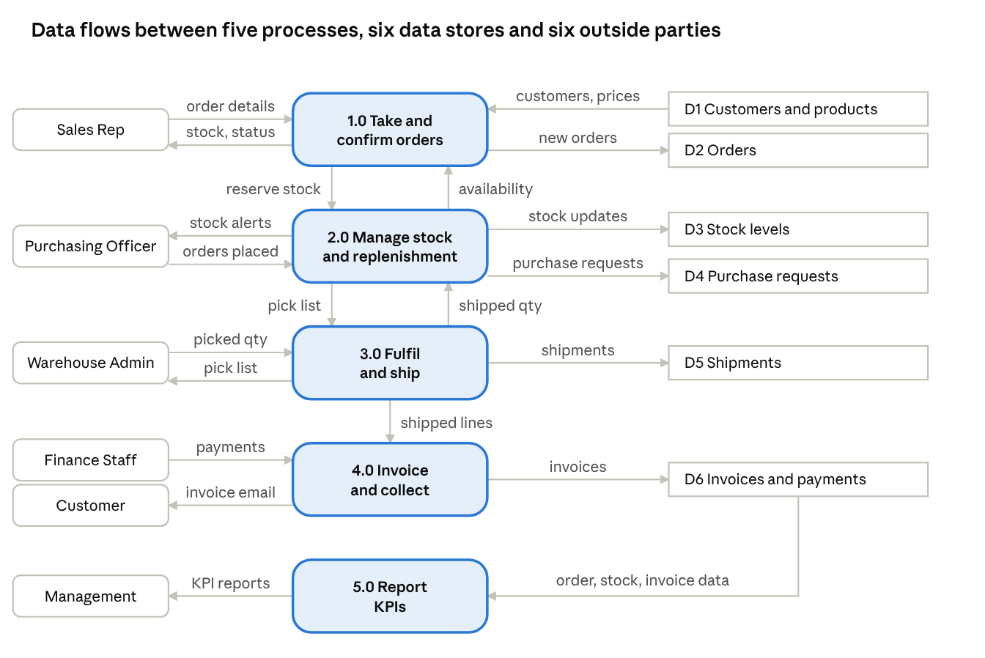
data flow diagram level 1 · 5 processes, 6 data stores, 6 outside parties
Process | What it does | Data stores | Business requirements
1.0 Take and confirm orders | Captures the order, shows stock, checks rules, asks for reserve | D1, D2 | BRQ-01 to BRQ-05
2.0 Manage stock and replenishment | Holds, releases and adjusts stock; raises purchase requests | D3, D4 | BRQ-04, BRQ-10, BRQ-11
3.0 Fulfil and ship | Pick list, picking, shipment, partial shipment | D5 | BRQ-06
4.0 Invoice and collect | Invoice at shipment, email, payments, corrections | D6 | BRQ-07 to BRQ-09
5.0 Report KPIs | Reads order, stock, and invoice data for management | D2, D3, D6 | BRQ-12

